OneDrive is a UTSA’s cloud storage solution that provides one terabyte of storage as the standard allocation. In addition, use case expansions can be requested for up to five terabytes of storage. All UTSA students, faculty, and staff have access to OneDrive. OneDrive for Business provides a fast, easy way to store, sync, and share your files. Saved in the cloud, your files are quickly accessible from any internet-connected device. OneDrive for Business can easily sync your files across multiple devices. You can even access earlier versions of the files by checking out the version history. OneDrive is approved for Category I, II, and III data and is HIPAA and FERPA-compliant.
- For more information on data classifications at UTSA, click here.
- To understand more about Category I data, click here.

Use case for OneDrive?
OneDrive is recommended for personal and shared storage that does not require high computing capabilities with a capacity of one to five terabytes. Requesting additional storage beyond the one terabyte standard allocation requires a use case description and approval from University Technology Solutions.

Contents
HOW TO ACCESS 3
Web Browser 3
Desktop Application 5
Mobile App 10
Backup Data to OneDrive 11
Automatically Back up files. 11
Manually Back up files 14
Desktop Application 14
Web Browser 17
Sharing Files 19
From the Web Browser 19
OneDrive for Business Features 23

HOW TO ACCESS
There are three ways to back your data to OneDrive. One option is through the web browser, locally connecting the OneDrive to your computer, and the mobile app.
The option for the web browser requires minimal setup and maybe a faster option to get started, but it will require you to go to your web browser for access. The local connection is great for easy access to the files once the connection is established, but it does require a process to establish the connection. Although both are great options, it will be based on your use case of which process works best for you.
How would you like to Access OneDrive?
- Web Browser
- Desktop Application
- Mobile App

Web Browser
- Visit myUTSA or click on the link https://my.utsa.edu/
- Click OneDrive for Business under “Faculty/Staff Resources.”
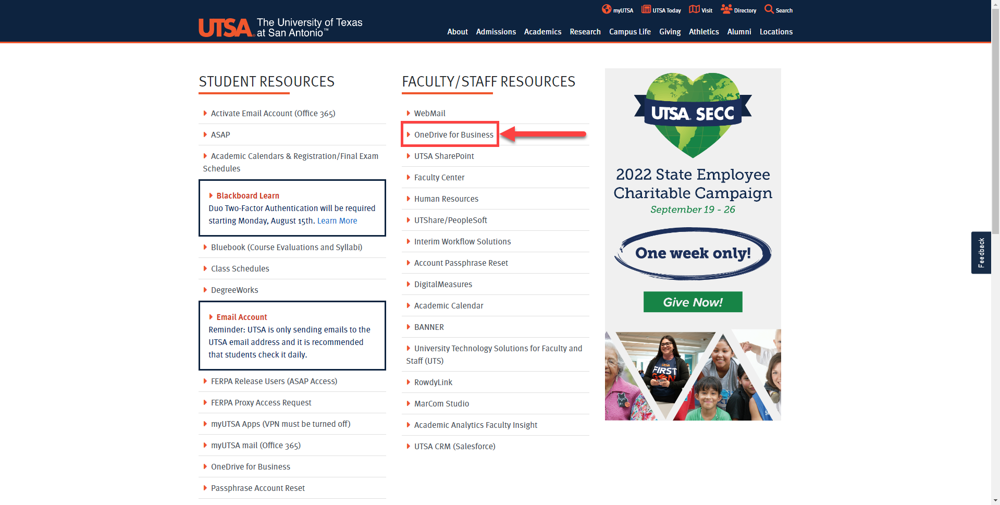

- Sign in with your firstname.lastname@utsa.edu and passphrase.
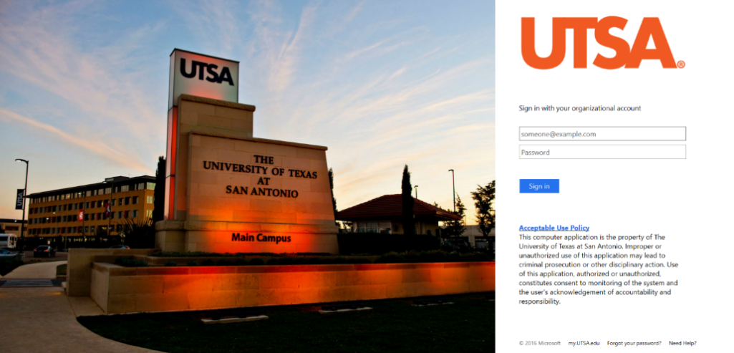

- Verify your account with Duo authentication. https://security.utsa.edu/duo-setup/
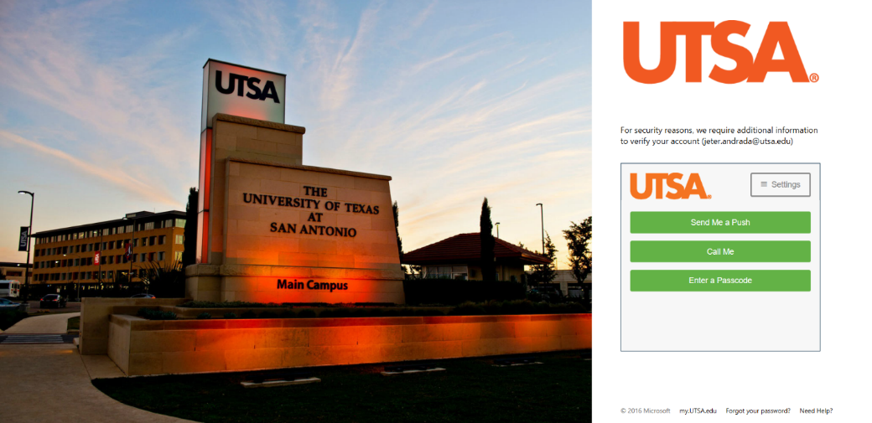

- You now have access to your OneDrive.
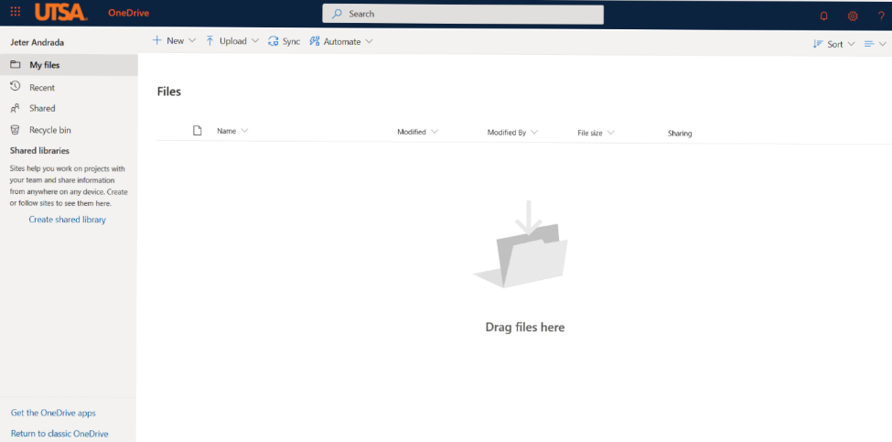

Desktop Application
If you haven’t already, you can install OneDrive by following the
- Go to your start menu.
- Select “Programs.”
- Click on “OneDrive,” NOT OneDrive for Business.
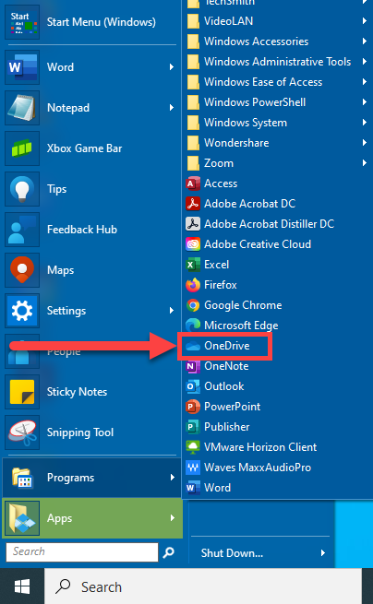

- Once the prompt opens, enter your UTSA email address and click “Sign In.”
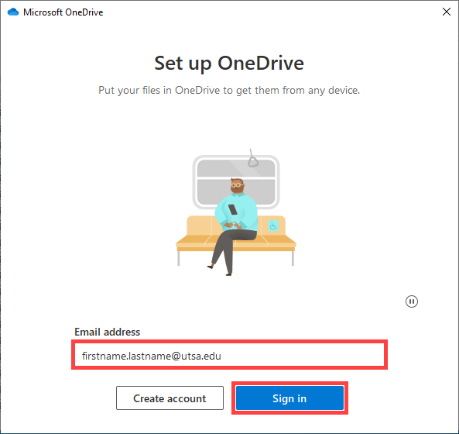

- You will automatically go to the University login prompt; please enter your UTSA passphrase.
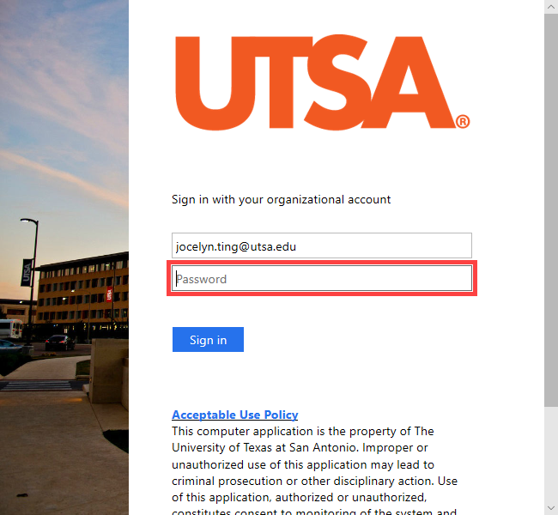

- The following prompt shows you where the folder will be located on your computer. Please click “Next.”
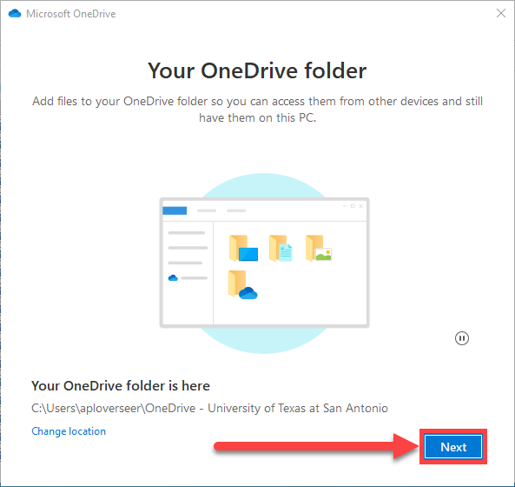

- In the next window, you can decide if you would like to back up your Desktop, Documents and Pictures automatically.
  - This option can be changed later if you decide to deselect all or keep all items selected.
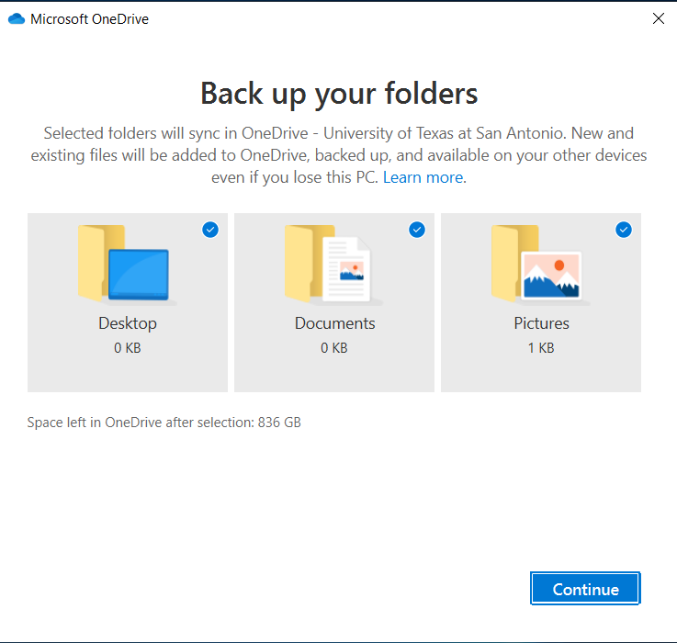

  - If you deselected the folders, the button would change to skip. Please click it to move on.
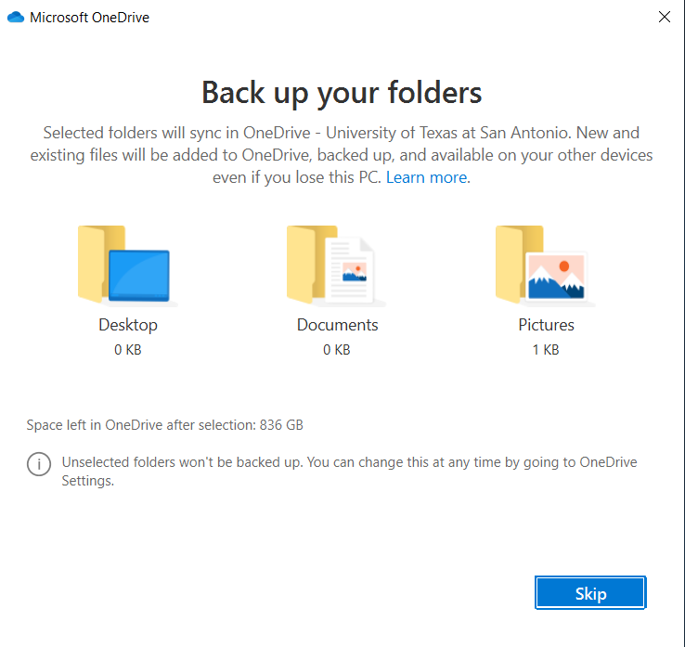

- Click “Next.”
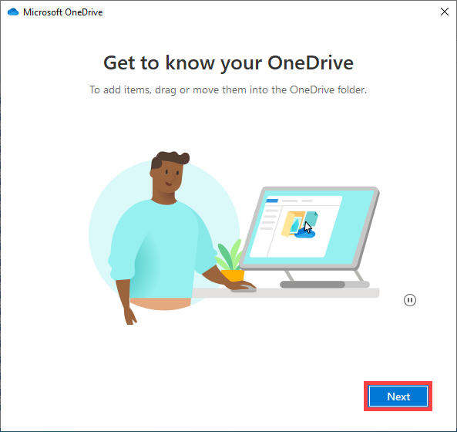

- Click “Next.”
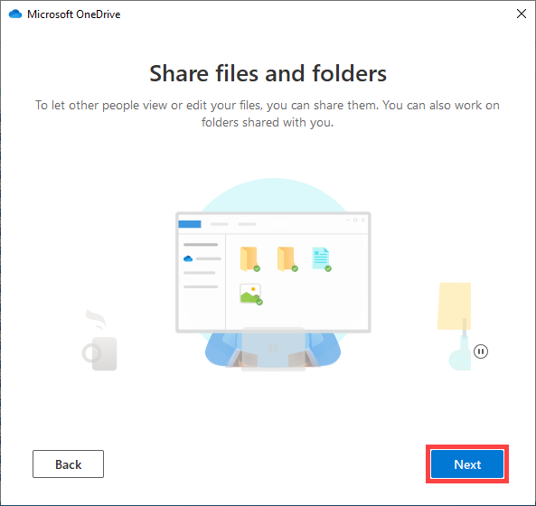

- Click “Next.”
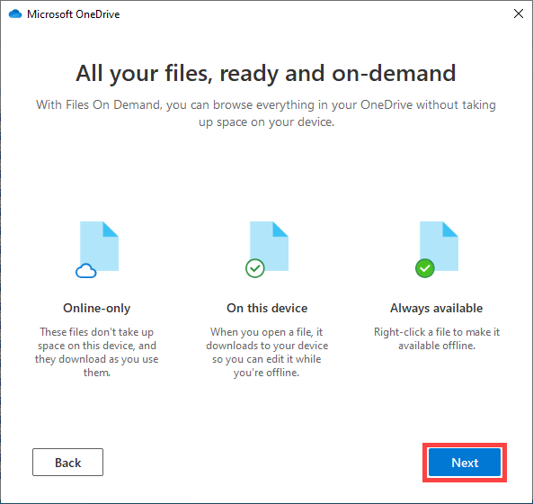

- Select “Later,” as we do not want to set up your phone at this time.
  - If you would like to set up your phone with OneDrive, you can follow the steps here.
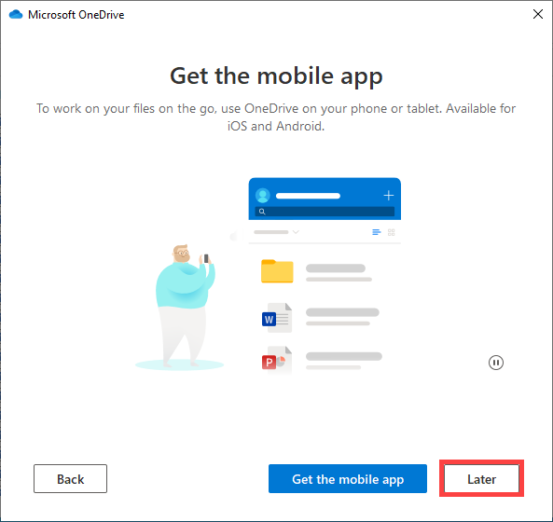

- It is now ready; please click “Open my OneDrive folder.”
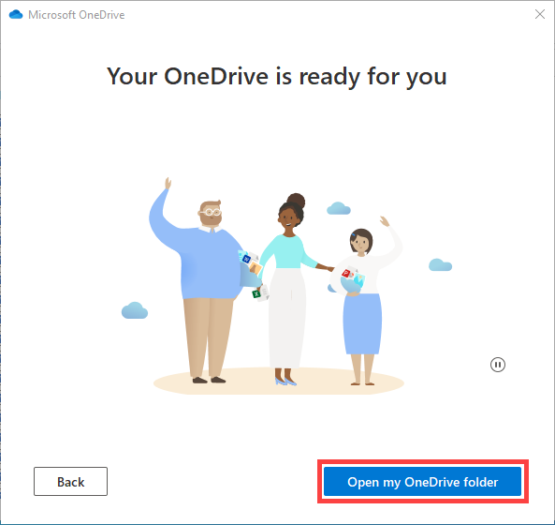

- Your OneDrive folder will now be open.
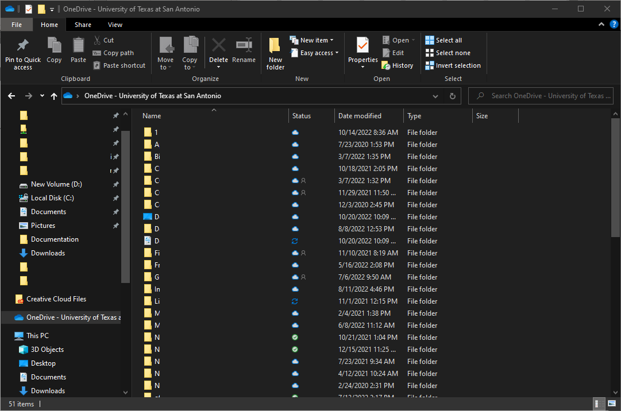

Mobile App
- Install OneDrive on your mobile device by going to the app store on your phone and downloading OneDrive
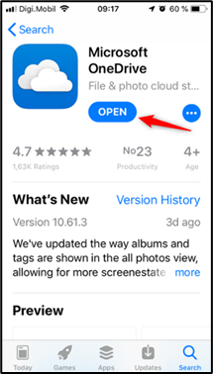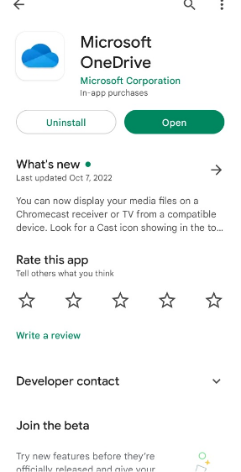
(Apple Apps Store) (Android/Google Play Store)

- Open the app and sign in using your UTSA-issued email address and passphrase.

- Complete Duo Two-Factor Authentication

- Success! All of your OneDrive files are now accessible via the mobile app. From here, you can send and share files. To edit files in your OneDrive, you can also use the entire Office suite of applications available as mobile apps.

Backup Data to OneDrive

There are two ways to back your data to OneDrive. You can automatically sync folders (Desktop, Documents, and Pictures) or manually back files up.

For application access, please use the steps located in one of the following sections
- Use the Web Browser
- Local Connection

Automatically Backup files.
OneDrive has the ability to back up your Desktop, Documents, and Pictures automatically. This can be set up during installation, but if not, we can change those settings.
- When OneDrive is actively running on your computer, the quickest way to find your OneDrive is to right-click the icon in the bottom right corner of your screen. It can either be found directly on your taskbar or within the icon tray.
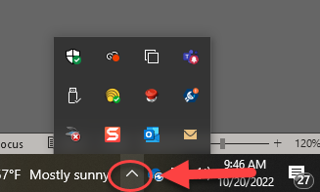
(Taskbar icon) (Icon Tray)

  - If you do not see OneDrive at the previously mentioned location, go you your start menu, select “All Programs,” and open OneDrive. Once open, locate OneDrive in the areas mentioned in the previous step.

- Right-click on the OneDrive icon and click the gear for settings.
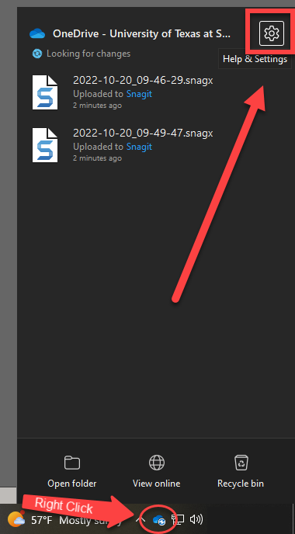
- Open Settings
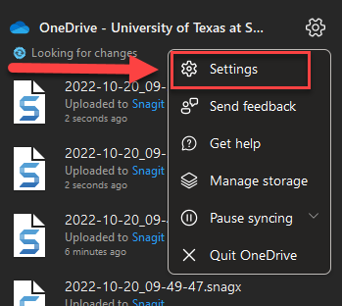

- Select the tab for “Backup.”
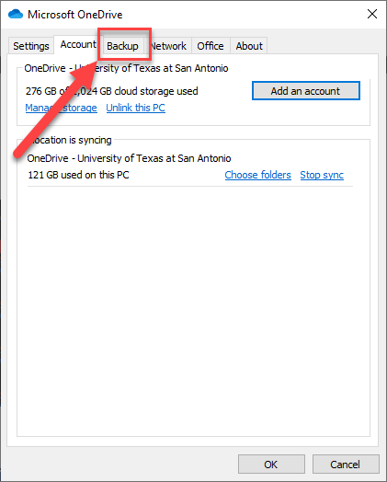

- Click “Manage Backup.”
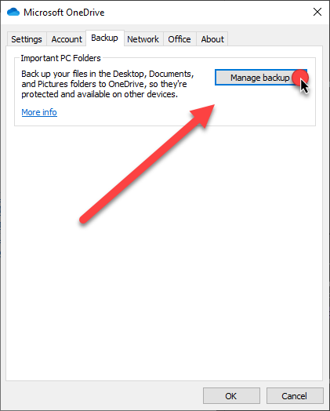

- If you see the following message, your Desktop, Documents, and Pictures are already being backed per a UTS policy.
  - If not, please select the folders you wish to back up.
  - If you want to back up a file not listed, you will need to either move that file to one of these locations or Manually move the file to OneDrive.
    - Steps can be found here.
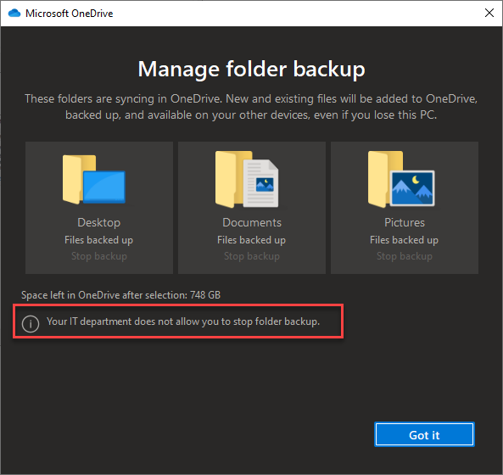

Manually Back up files

Desktop Application
- Locate and open your OneDrive applications.
- Leave the OneDrive folder open. We will now open a second window to start backing up your folder.
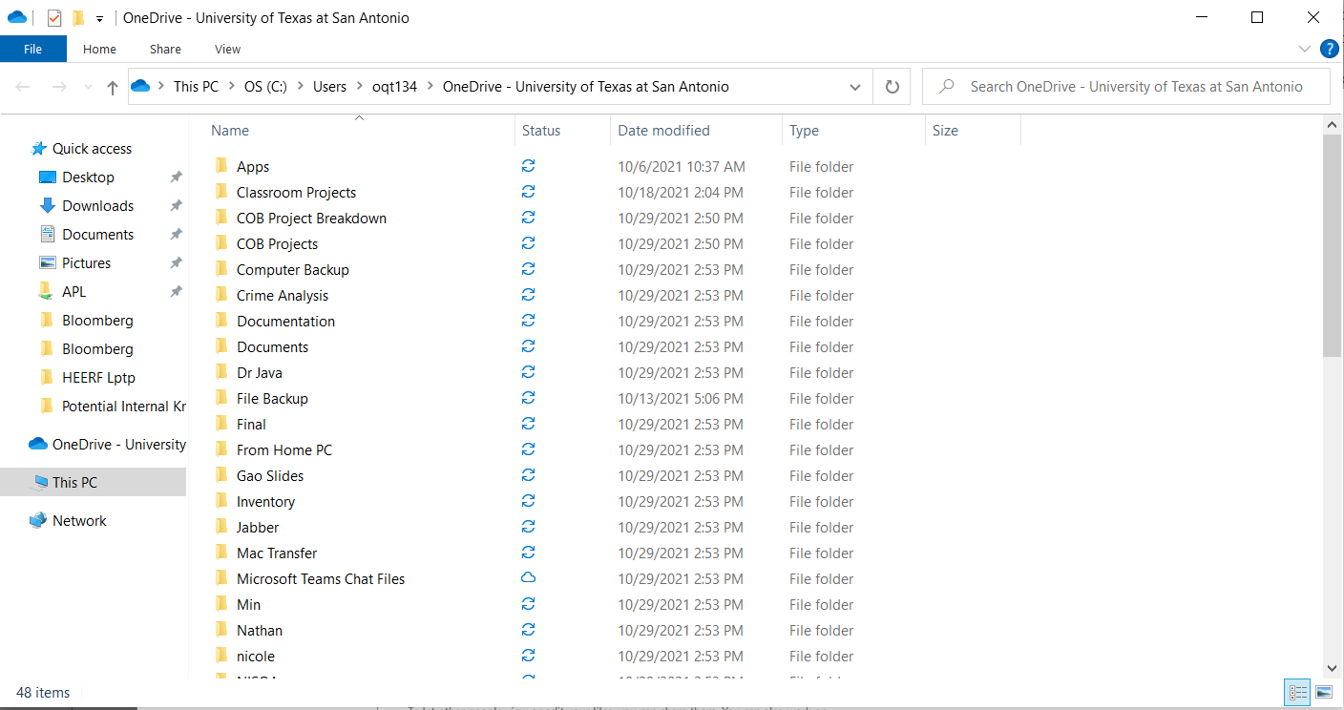

- At the bottom of your computer screen, right-click on the folder icon. Then select “File Explorer.”
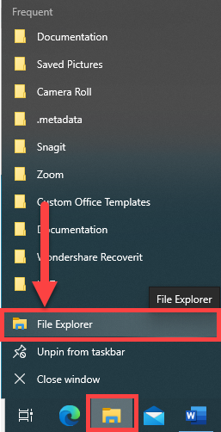

- On the left side of the window, locate and click on “Local Disk (C:).”
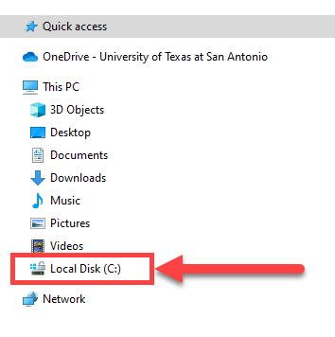
- Double-click “Users.”

- Double-click on your abc123.
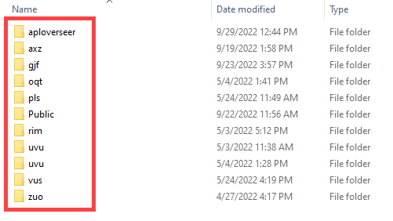

- Once open, put the OneDrive folder you left open and the user folder you just opened side by side. You will want it to look something similar to this:
(Local Computer Side) (OneDrive Side)
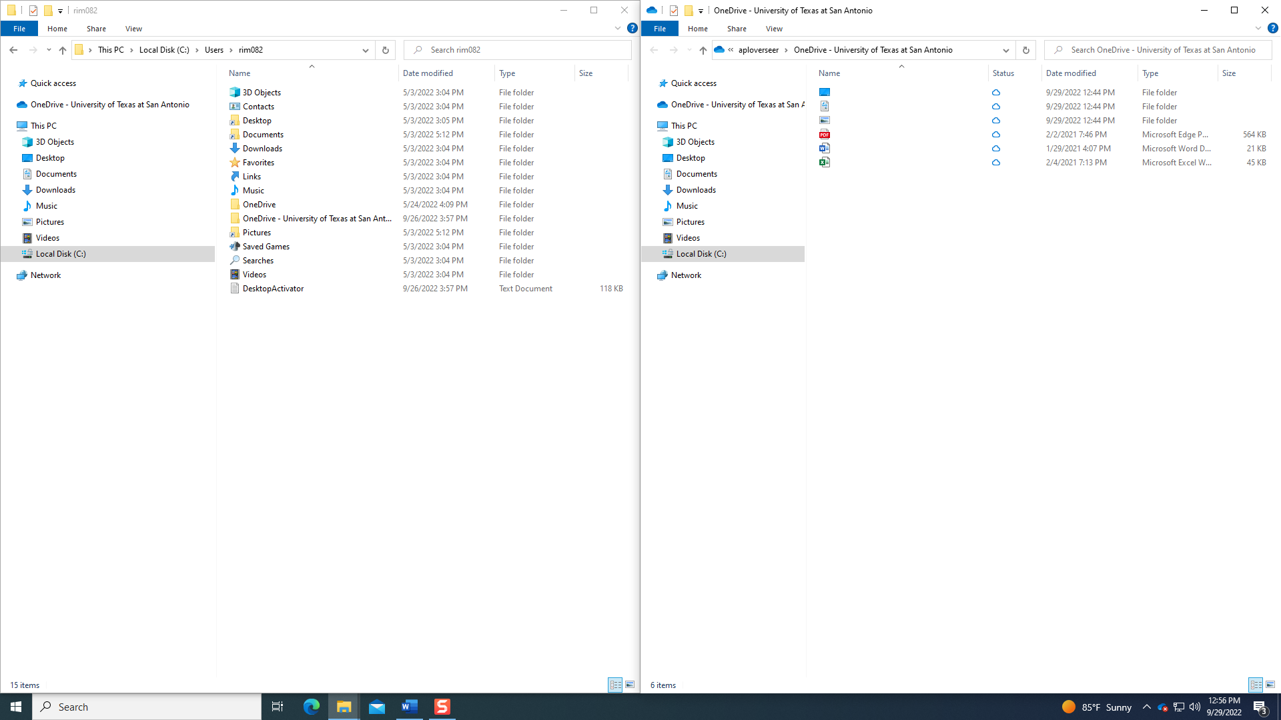

- Using the Local Computer Side, locate the file or folder you wish to backup, right-click, select “Copy,” and then paste it into the OneDrive side.

  - Copy from computer:
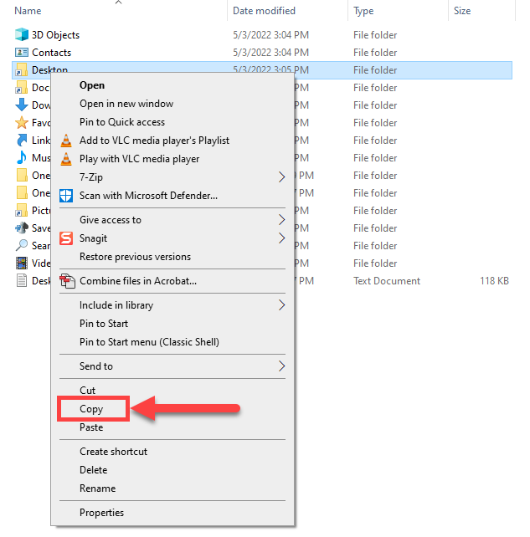
  - Paste in OneDrive:
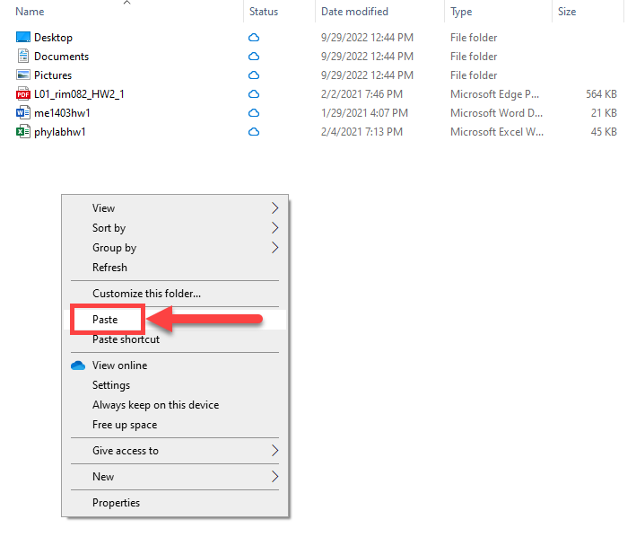
- OneDrive will now sync these folders to the Server.
- If you have any issues, please contact Academic Computing.

Web Browser
- Access your OneDrive.
  - Steps can be found here.

- To upload files onto OneDrive, click on Upload and choose if you are uploading files or a whole folder.
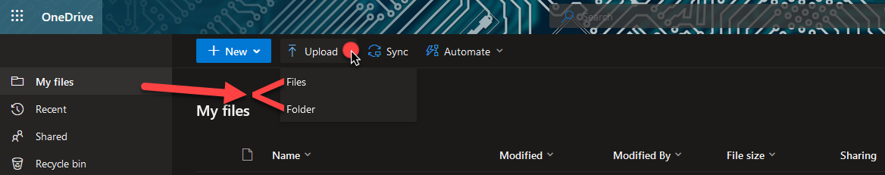

- Upload one or more files:
  - After clicking “Upload,” select “Files
- Navigate to where your file(s) are stored.
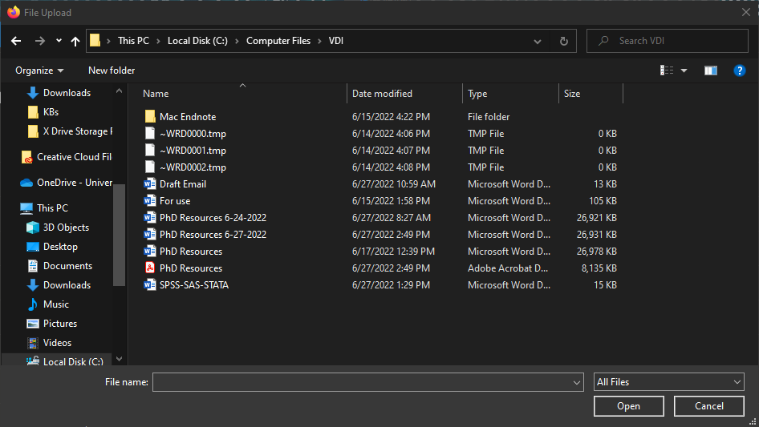

- Click on the file(s) you want to upload and click open.
  - To select more than one file, hold down the control key (ctrl) while selecting your files.
    - Only do this for the folder you are currently in. If you want files from another folder, make it a separate upload or copy all the files to a folder and upload the folder.
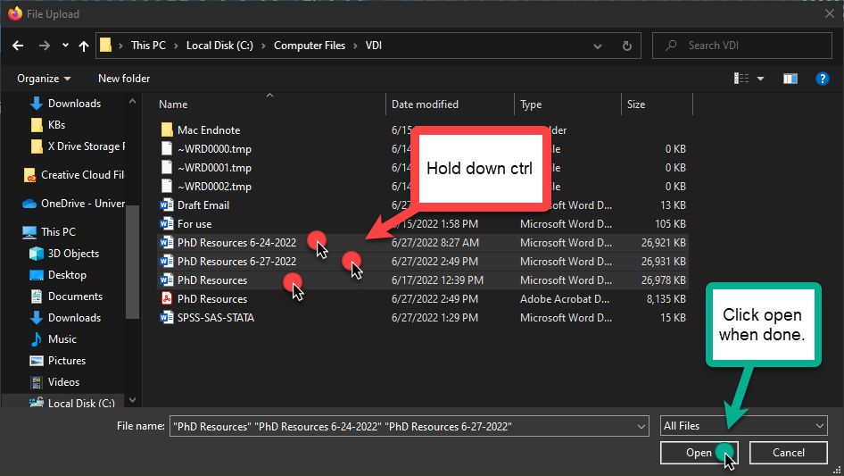
- Your files will start uploading. As they upload, they will appear on the screen.
  - You can also check the status of an upload on some of your larger files.
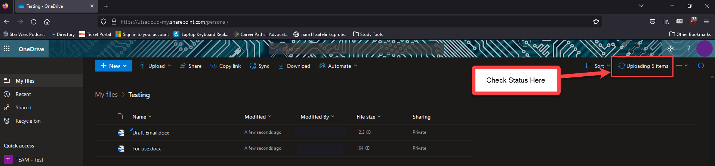

Sharing Files
You can easily share files with colleagues or students with OneDrive. Simply upload the files you wish to share and then share the file or folder.

From the Web Browser
- Select the folder or file(s) you are sharing.
  - To select multiple files, click on the bubble to the left of each file.
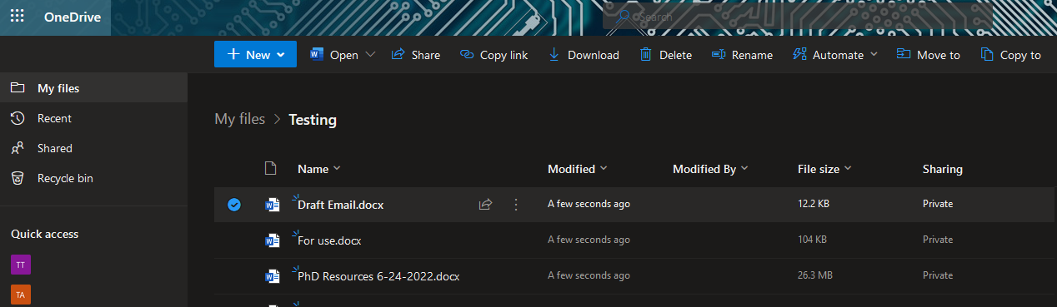

- Click Share.
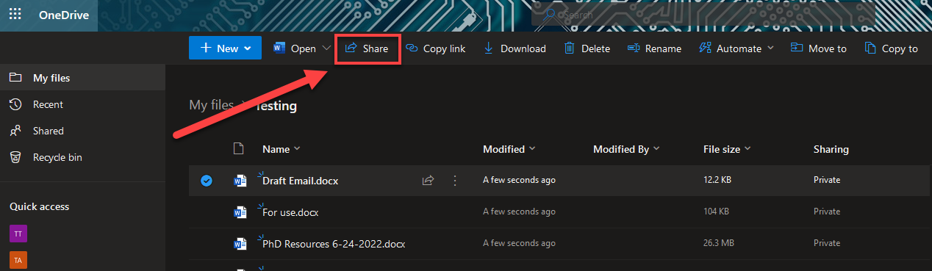

- In the pop-up, you can check the access setting for the link.
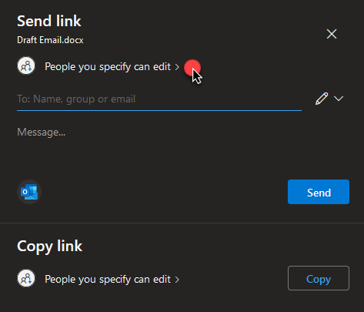

- You can restrict the link settings by picking who can edit or access.
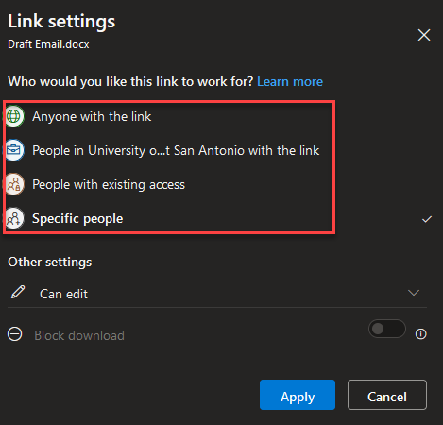

- You can also change what abilities the person you share with can have.
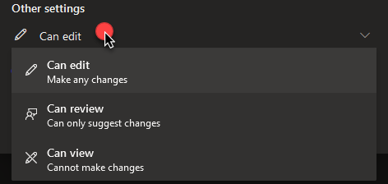

- Once you have made your selections, you will see a new set of prompts where you have the options to put a time limit, password protection, and even block downloads. When done, click “Apply.”
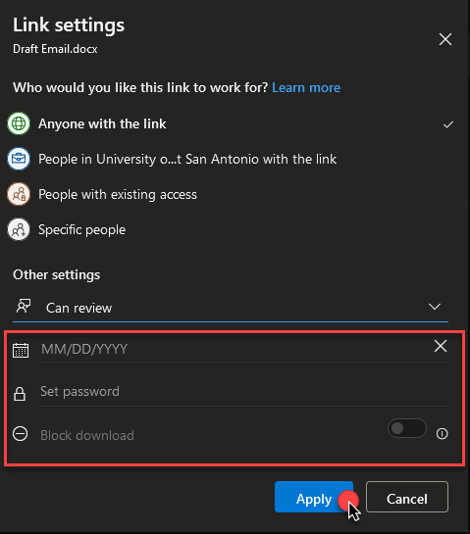
- Enter the email with who you would like to share.
  - You also have the option to add a message before sending.
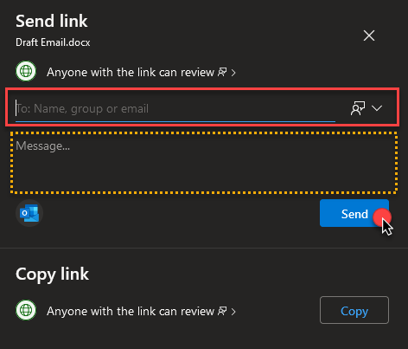

- If you just want a link to the file, you can click copy under the Copy link.
  - You can also modify the link settings similar to step 6.
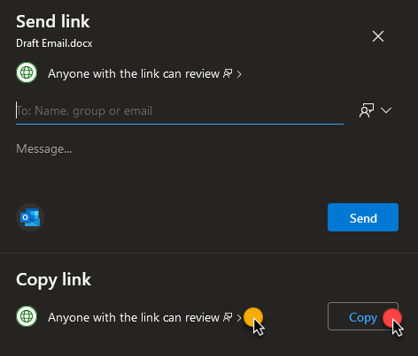

- Once you click send, a small screen will appear and say, “Link to ‘Filename.ext’ sent.”
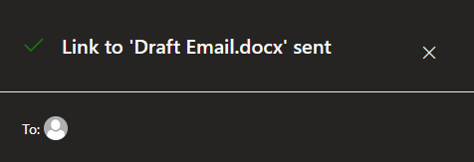

- The recipient will see this notification.
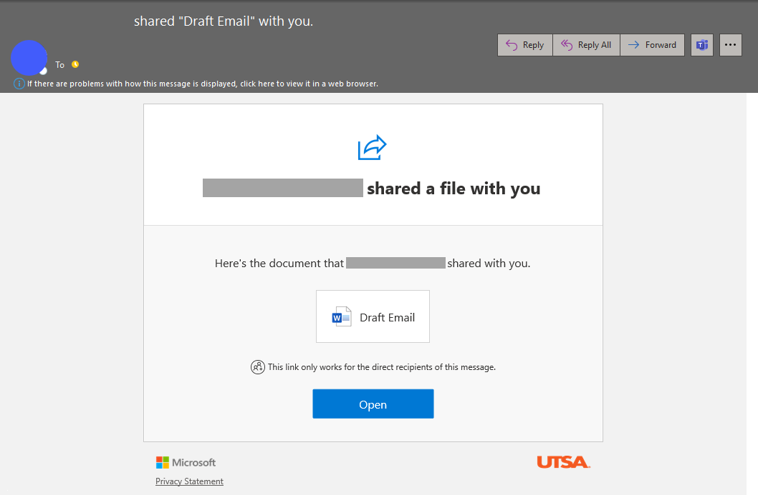

OneDrive for Business Features

Office Integration
MS Office applications automatically view OneDrive as a storage library. You can access your files using the integrated online versions of office. You can view files and make edits from anywhere with an internet connection
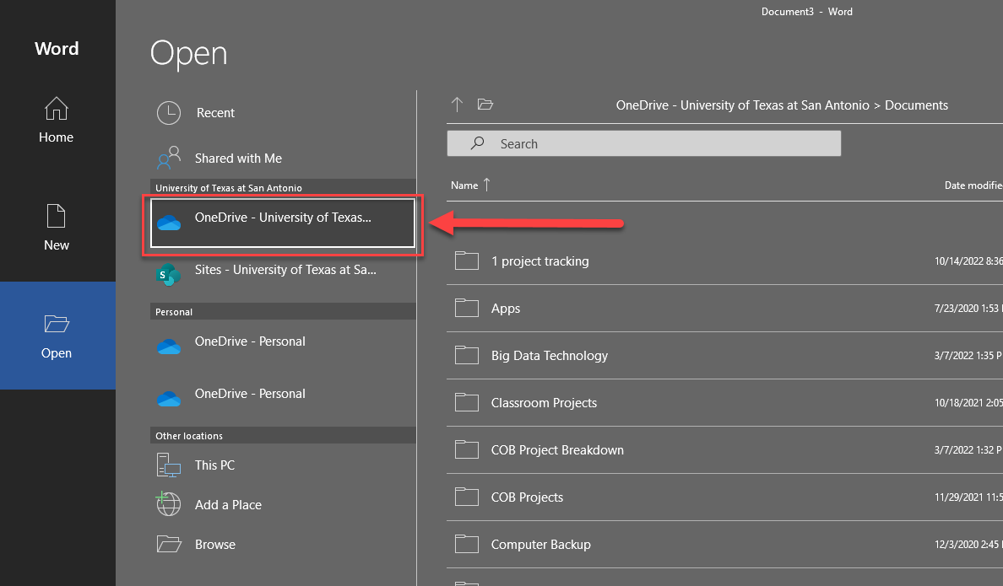

Co-authoring
Multiple people can edit a document simultaneously.
Just choose the file you want to edit, and OneDrive will save the edits automatically with the names of the people that edited the document.
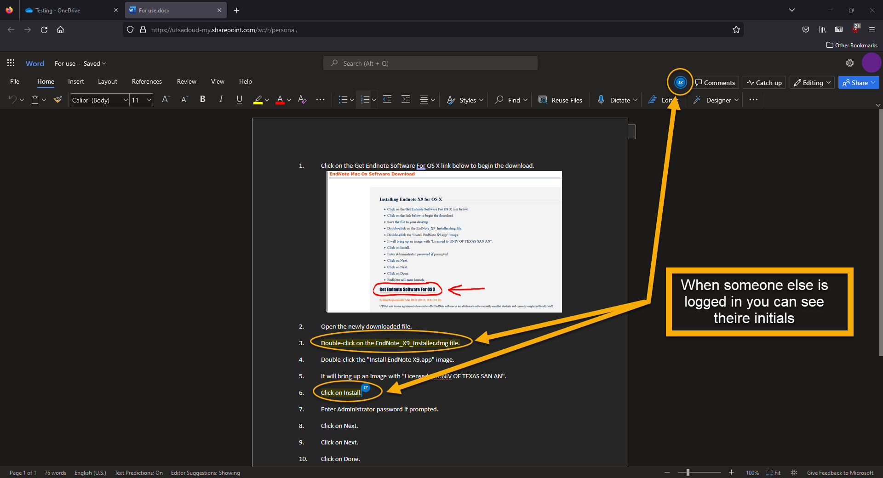

Version Control
OneDrive keeps multiple file versions, so you can easily recover a corrupted file or recover a file you want to revert back to the original version.
- Click the three dots next to the file and select “Version history.”
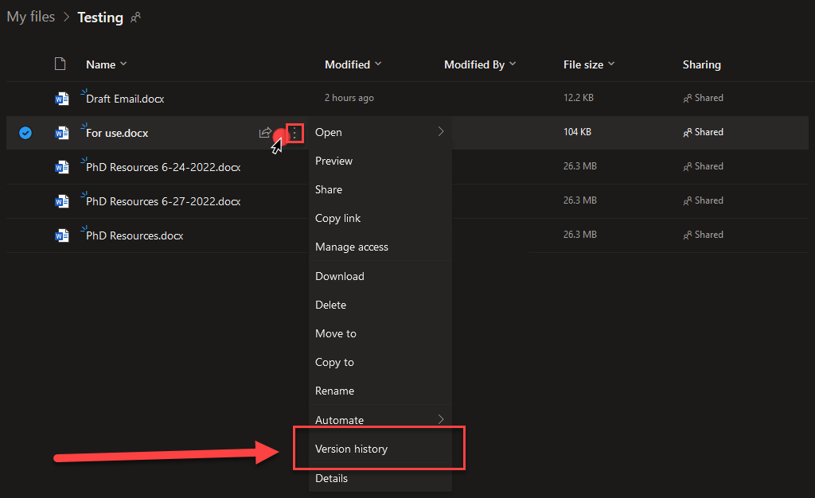
- Select the version you want, choose restore, and the version will restore back to the chosen edit.
